**SOFTWARE**

**REQUIREMENTS**

**SPECIFICATIONS**

**For**

**Job Search Website**

**Prepared By:-**

**Alwin Jebastine M**

**Kabilan G**

**Mouleeswaran R**

**Vijay K**

**Academic Year: 2023 - 2024**

**1.Introduction:**

**1.1 Purpose:**

The main objective of this document is to illustrate the requirements of the project Job Search Application.This document gives detailed description of the both fundamental and non-fundamental requirements proposed by the clients.The main purpose of this project is to help individuals find and secure employment opportunities that align with their skills, qualifications, career goals, and personal preferences. Job search applications serve as a crucial tool for both job seekers and employers. This project describes the hardware and software requirements using ER diagrams and UML diagrams.

**1.2 Document Conventions:**

* Convention for Main Title:
* Font Style :Bold
* Font Size : 14
* Font Face : Times New Roman
* Convention for Sub Title:
* Font Style: Bold
* Font Size: 12
* Font Face: Times New Roman
* Convention for Body:
* Font Face: Time New Roman
* Font Size: 12

**1.3 Scope of Development Project:**

Job Search Application is basically a software or mobile application designed to assist individuals in finding employment opportunities that match their skills, qualifications, and career preferences. These applications are commonly used by job seekers to streamline the job search process and connect with potential employers.The Project is specifically designed for the use of job seekers and employers.The product will work as a complete user interface for

The project can be easily implemented under various situations. We can add new features as and when we require, making reusability possible as there is flexibility in all the modules. The language used for developing the project is Java as it is quite advantageous than other languages in terms of performance, tools available, cross platform compatibility, libraries, cost (freely available), and development process.

**1.4 Definitions, Acronyms and Abbreviations**

ER-> Entity Relationship

UML -> Unified Modeling Language

IDE-> Integrated Development Environment

SRS-> Software Requirement Specification

IEEE ->Institute of Electrical and Electronics Engineers

**1.5 References**

* Websites - [IEEE](https://ieeexplore.ieee.org/abstract/document/9752295/), [ScienceDirect](https://www.sciencedirect.com/science/article/pii/S2666412721000489)

**2.Overall Descriptions**

**2.1 Product Perspective**

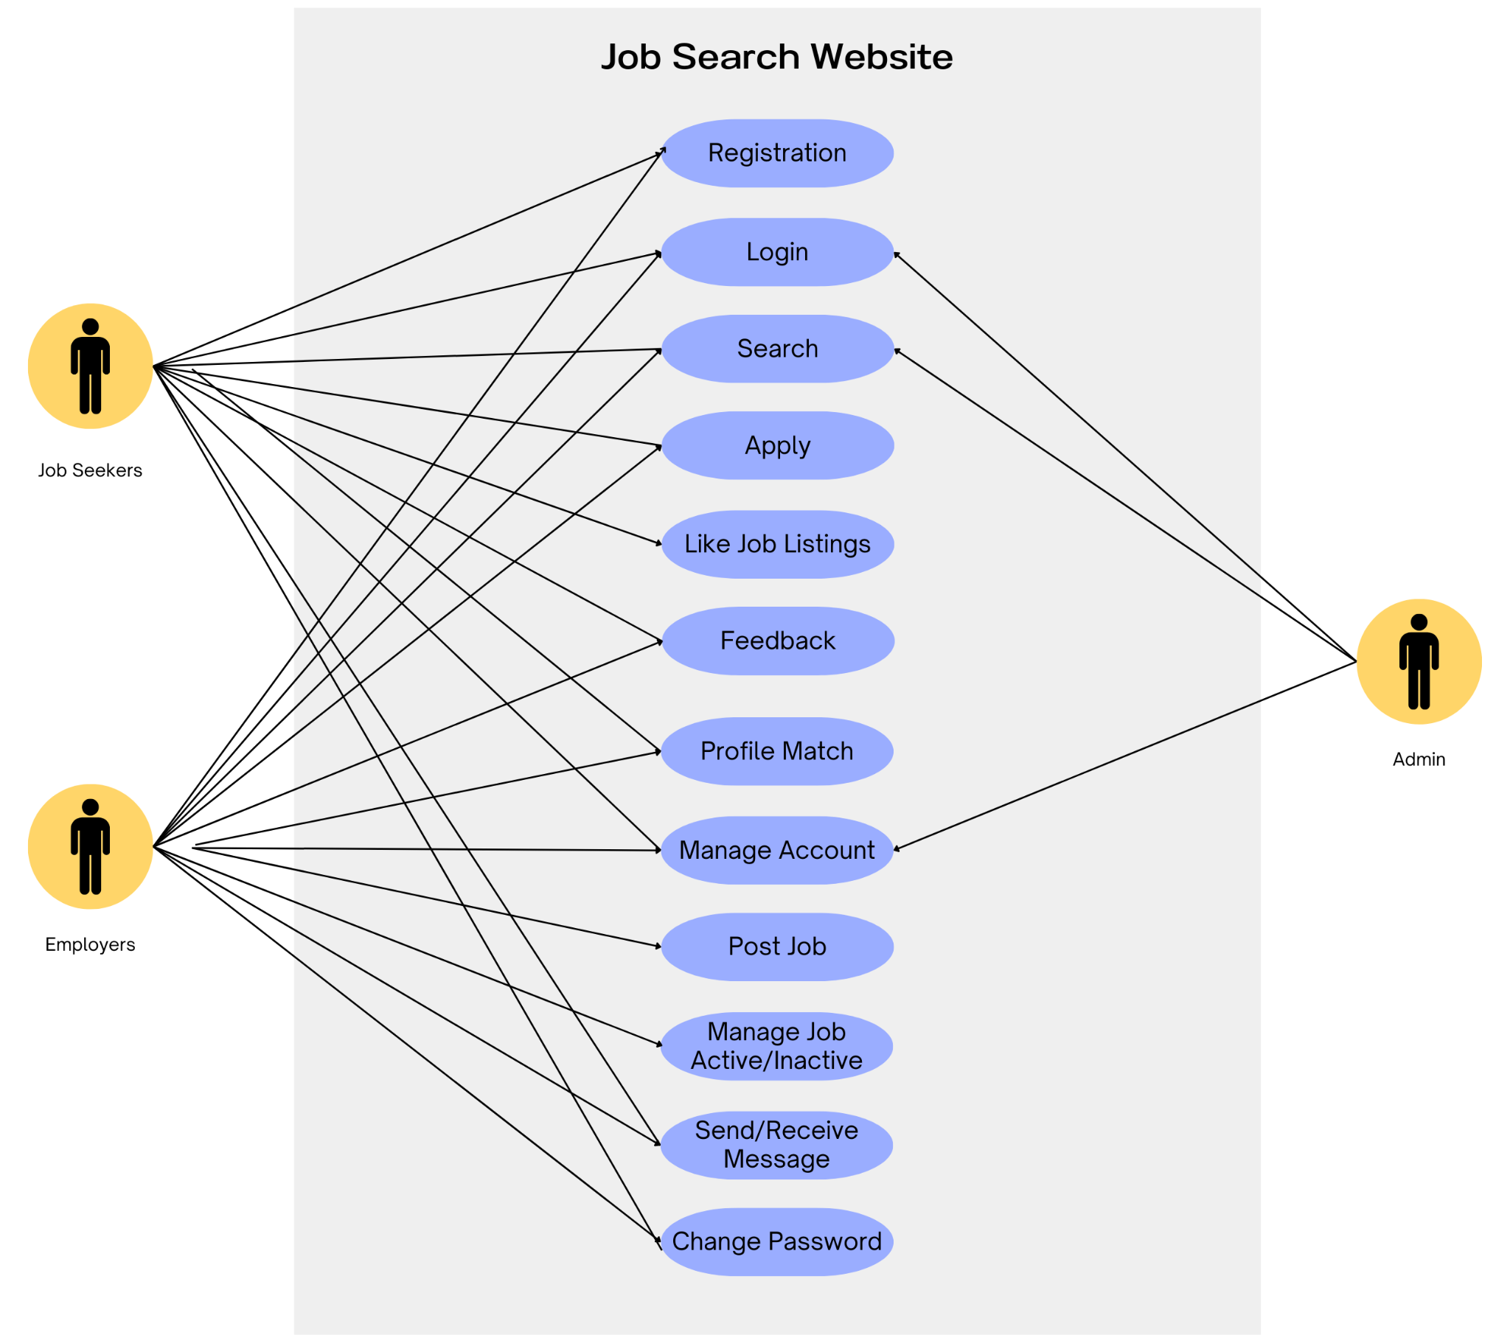

**2.2 Product Function**

Entity Relationship Diagram of Job search portal.

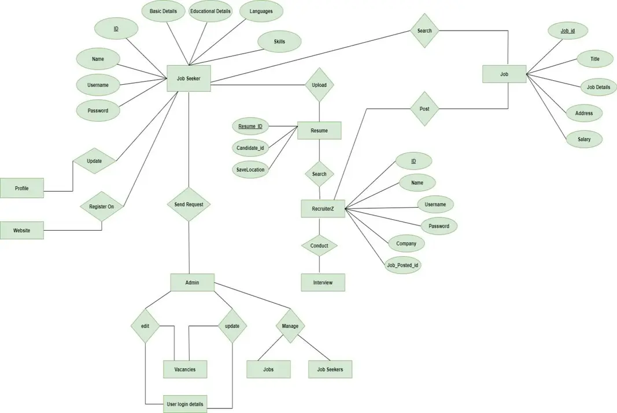

* Firstly, the application makes it mandatory for both job seekers and job recruiters to sign up in the application to avoid fraudulent activities.
* Then, The application allows the user to search for jobs that match with their requirements or interest which they mentioned during registration while it allows the job recruiters to post their available job in the website and it wont allow them to do it without verifying their profile.

**2.3 User Classes and Characteristics**

The system provides different types of services based on the type of users[Employer/Employee]

The features that are available to the Employer are:-

* Post and manage job listings for open positions within their company.
* View and sort through resumes and applications submitted by job seekers.
* Contact job seekers directly through the platform.
* Access analytics and reports on job listing performance.
* Edit and update company profile information.
* Receive notifications about new job applications.
* Manage multiple user accounts for company representatives.

The features that are available to the Employee are:-

* Apply to job listings by submitting resumes and cover letters.
* Save favorite job listings.
* Receive notifications about job matches and updates.
* View their job application history.
* Edit and update personal contact and resume information.
* Communicate with employers who have shown interest.
* Search and view job listings based on various criteria (e.g., job title, location,salary).
* Create and manage a personal job seeker profile.

**2.4 Operating Environment**

* The product will be operating in any OS environment.
* The Job Search Application is a website and shall operate in all famous browsers, for a model we are taking Microsoft Internet Explorer,Google Chrome,and Mozilla Firefox.Also it will be compatible with IE 6.0.
* Most of the features will be compatible with the Mozilla Firefox & Opera 7.0 or higher version.
* The only requirement to use this online product would be the internet connection.The hardware configuration includes Hard Disk: 40 GB, Monitor: 15” Color monitor, Keyboard: 122 keys. The basic input devices required are keyboard, mouse and output devices are monitor, printer etc.

**2.5 Assumptions and Dependencies**

The assumptions are:-

* May not work for all earlier versions of web browsers since it will be built using react.

The dependencies are:-

* Latest version of web browsers along with operating systems that support those.

**2.6 Requirement**

Software Configuration:-

* Web Browser with stable internet connection
* Mac/Linux/Windows Operating System

Hardware Configuration:-

* 512mb RAM
* Dual core Processor
* Network Interface Controller for Internet

**2.7 Data Requirement**

* Job Seeker Data:
  + User profiles (name, contact details, resume, skills, preferences, application history).Saved job listings.Job application records (date, status, associated job listing).
* Employer Data:
  + Company profiles (name, contact details, company description, logo).Posted job listings (title, description, requirements, location, posting date, etc.).Received job applications (applicant details, submission date, status).
* System Outputs:
  + When job seekers request details of their accounts, the system should provide:Account creation date and time.Job application history (job title, application date, status).Saved job listings.When employers request details of their accounts, the system should provide:Account creation date and time.List of posted job listings..
* Database Queries:
  + SQL queries or NoSQL operations to retrieve and update user data, job listings, and application statuses.Queries for generating reports and analytics (e.g., job listing performance, applicant demographics).

**3. External Interface Requirement**

**3.1 GUI**

* User-Friendly Interface:
  + The software should provide a user-friendly graphical interface for job seekers and employers.
* Quick Reports:
  + Users (job seekers and employers) should have the ability to view quick reports, such as application and job posting statistics, within specified time frames.
* Customization:
  + The GUI should allow the administrator to customize the appearance and layout of the website to align with branding and design preferences.
* Simplicity and Consistency:
  + The GUI design should prioritize simplicity and consistency throughout the website.
* Template:
  + The user interface should include a dedicated area for user management, including registration and login/logout functionality.
* Search:
  + Job seekers and employers should have a search feature that allows them to search for job listings based on various criteria, such as job title, location, and keywords.
* Administrator's Control Panel:
  + The administrator should have access to a control panel to manage user accounts, review and moderate job listings, and configure system settings.
  + Features may include adding or removing users, managing job listings, and configuring search and display options.

**4.System Features**

* User Authentication and Validation:
  + Proper validation procedures should be in place to verify the authenticity of user information during registration and login processes.
* Account Monitoring:
  + The administrator should have the capability to monitor and manage user accounts effectively.
  + The system should generate notifications or pop-up messages when users attempt actions that exceed specified limits or violate site rules. For example, job seekers trying to apply to an excessive number of jobs within a short time frame might trigger a pop-up warning.
  + An automated system for tracking and assigning penalties, if applicable, should be in place.
* Proper Accountability:
  + Users should have confidence in the privacy and security of their accounts. They should not have access to other users' personal information or account details.
  + The administrator should have exclusive access to view and manage all user accounts, including the ability to review and modify account details, roles, and permissions.
  + These system features are essential for maintaining the security and trustworthiness of a job searching website.

**5.Other Non-functional Requirements**

**5.1 Performance Requirement**

* Efficiency and Accuracy:
  + Search queries for job listings, candidate profiles, and other information should be processed efficiently to minimize response times.
* Error Handling:
  + The system should effectively handle both expected and unexpected errors without compromising data integrity or causing extended downtime.
* Scalability:
  + It should accommodate a growing number of job listings, user profiles, and interactions without performance degradation.
* Resource Optimization:
  + This includes efficient database queries, memory management, and load balancing to distribute server resources effectively.
* Caching and Indexing:
  + Implement caching and indexing mechanisms to enhance performance.
  + Effective indexing of the database can speed up search operations and improve overall system performance.
* Load Testing:
  + Conduct load testing to simulate high user traffic and evaluate how the system performs under heavy loads.
  + Identify and address any bottlenecks or performance issues that arise during load testing to ensure system stability during peak usage.

**5.2 Safety Requirement**

* Regular automated backups of the website's database should be scheduled to prevent data loss in the event of database crashes, viruses, or operating system failures.
* To prevent service interruptions caused by power supply failures, the hosting infrastructure should include Uninterruptible Power Supplies (UPS) or inverters.
* Implement robust security measures to protect user data from threats such as viruses, malware, and cyberattacks.
* Utilize encryption protocols to safeguard sensitive information, such as user credentials and personal data.
* Implement strict access control mechanisms to ensure that only authorized personnel have access to critical systems and data.
* Regularly review and analyze logs to identify and respond to security incidents promptly.

**5.3 Security Requirement**

* The website should use a secure database system that employs encryption and access controls to protect sensitive data.
* Users should not be able to edit or modify data that doesn't belong to them, except for their personal information and certain other details relevant to their profiles
* Different types of users (job seekers, employers, administrators) should have distinct access levels and privileges.
* Passwords should be securely stored using industry-standard hashing and salting techniques to prevent unauthorized access.
* Regular members should not have direct access to the database, and only administrators should have the rights to update or modify the database..
* Conduct regular security training for administrators and users to educate them about security best practices and how to protect their accounts.

**5.4 Requirement attributes**

* Administrators should have different access levels and permissions to manage various aspects of the system.
* This open-source nature encourages collaboration, community contributions, and transparency in the development process.
* The database design should prioritize user-friendliness to ensure that all users, including job seekers and employers, can easily navigate and interact with the system
* .Data should be organized logically, and user interfaces should be intuitive and well-designed.
* The system should be designed for easy installation and setup, allowing users to quickly download and install it on their preferred platforms.

**5.5 Business Rules**

* All users, including job seekers, employers, and administrators, must adhere to the rules and regulations set forth by the website.
* Job seekers and employers should follow data security guidelines to protect their accounts and sensitive data.
* Employers should provide accurate and truthful information when posting job listings.
* Job listings should comply with relevant labor laws and regulations.
* Users should ensure that their actions on the website comply with all applicable laws and regulations in their respective jurisdictions.

**5.6 User Requirement**

The users of the system are employers and employees of the society.The members are assumed to have basic knowledge of the computers and internet browsing. The administrators of the system should have more knowledge of the internals of the system and is able to rectify the small problems that may arise due to disk crashes, power failures and other catastrophes to maintain the system. The proper user interface, user manual,online help and the guide to install and maintain the system must be sufficient to educate the users on how to use the system without any problems.

* Backup and Recovery: The ability to perform regular backups of the system's data and the capability to recover data in case of data loss.
* Forgot Password: A feature to assist users in recovering or resetting their passwords if they forget them.
* Data Migration: When users register for the first time, their data should be securely stored on the server.
* Data Replication: Implement data replication mechanisms to ensure redundancy and data availability, even in the event of data loss at one location.
* Auto Recovery: Frequent auto-saving of user data to prevent loss of unsaved work.
* File Organization: Proper file organization and management to ensure efficient data storage and retrieval.
* Regular Server Maintenance: The server should be maintained and updated periodically to ensure optimal performance and security.

**6.Other Requirements**

**6.1 Data and Category Requirements**

The job searching website should categorize users into various groups, such as job seekers, employers, administrators, and support staff.Administrators may have the right to modify data, delete records, and make system-level changes, while other users typically have read-only access.Access to sensitive or confidential data should be restricted to authorized personnel only.The website should categorize job listings based on various criteria, such as industry, job type, location, and salary range.Each job listing should be associated with one or more categories to help users find relevant job opportunities.Job listings should be displayed based on the selected categories or criteria.The data related to each job listing category should be organized and presented in a consistent format.Each job listing should include key information such as job title, company, location, description, and application details.Users should be able to filter and sort job listings within each category based on their preferences.

**6.2 Appendix**

A:Admin, Abbreviation, Acronym, Assumptions;

B: Business rules;

C: Class, Client,Conventions;

D: Data requirement, Dependencies;

E:Employer,Employee;

J:Job seeker;

G: GUI;

K: Key;

M:Member;

N: Non-functional Requirement;

O: Operating environment;

P: Performance,Perspective,Purpose;

R: Requirement, Requirement attributes;

S: Safety, Scope, Security, System features;

U: User, User class and characteristics, User requirement;

**6.3 Glossary**

The following are the list of conventions and acronyms used in this document and the project

as well:

* Administrator: A login id representing a user with user administration privileges to the software
* User: A general login id assigned to most users
* Client: Intended users for the software
* SQL: Structured Query Language; used to retrieve information from a database
* SQL Server: A server used to store data in an organized format
* Layer: Represents a section of the project
* User Interface Layer: The section of the assignment referring to what the user interacts with directly
* Application Logic Layer: The section of the assignment referring to the Web Server. This is where all computations are completed
* Data Storage Layer: The section of the assignment referring to where all data is recorded
* Use Case: A broad level diagram of the project showing a basic overview
* Class diagram: It is a type of static structure diagram that describes the structure of a system by showing the system’s cases, their attributes, and the relationships between the classes
* Interface: Something used to communicate across different mediums
* Unique Key: Used to differentiate entries in a database

**6.4 Class Diagram**

